
Assignment #1

Submitted To: -

Dr. Sourabh Jain
Submitted By: -
ROHIT SAGAR
12111088
CSE (2021-2025)

Question 1: Write a program to find sum of n natural number using for loop.
Ans1.
#include <stdio.h>
int main()
{
int n, i, sum = 0;
printf("Enter the value of n: \n");
scanf("%d", &n);
for (i = 1; i <= n; ++i)
{
sum += i;
}
printf("Sum of n natural numbers is = %d", sum);
return 0;
}

OUTPUT: -
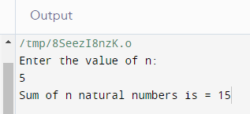

Question 2: Write a program to enter a number and checked whether it is divided by 2,7,11 or not using switch case.
Ans2.
#include <stdio.h>
int main(){
int n;
printf("Enter the number to be check the divisibility by 2,7and 11.\n");
scanf("%d", &n);
switch(n%2){
case 0: printf("No. is Divisible by 2.\n");
break;
default: printf("No. Not divisible by 2.\n");
}
switch(n%7){
case 0: printf("NO.Divisible by 7.\n");
break;
default: printf("No. Not divisible by 7.\n");
}
switch(n%11){
case 0: printf("No. Divisible by 11.\n");
break;
default: printf("No.Not divisible by 11.\n");
}
return 0;
}

OUTPUT: -
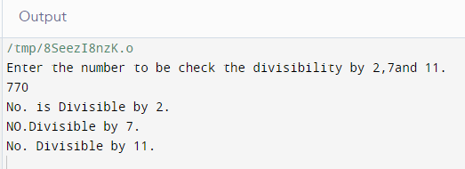

Question 3: Write a program to calculate GCD of two numbers.
Ans.3
#include <stdio.h>
int main(){
int a,b, min;
printf("Enter first number.\n");
scanf("%d", &a);
printf("Enter second number.\n");
scanf("%d", &b);
int GCD = 1;
if (a<b){
min =a;
}
else {
min = b;
}

for (int i = 2; i<=min; i++){
if (a%i==0 && b%i==0){
GCD = i;
}
}
printf("GCD is %d", GCD);
return 0;
}

OUTPUT: -
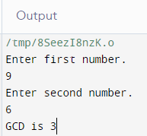

Question 4: Write a program to calculate Nth term of Fibonacci Series.
Ans4
#include <stdio.h>
int main()
{
int i, n, p, num1, num2, num3;
printf("Which term of fibonnaci series?\n");
scanf("%d", &n);
if (n==1){
printf("0\n");
}
else if (n==2){
printf("1\n");
}
else if (n>2){
num1 = 0;
num2 = 1;
for (int i = 3; i < n+1; i++)
{
num3 = num2 + num1;
num1 = num2;
num2 = num3;
}
printf("%d\n", num3);
}
return 0;
}

OUTPUT: -
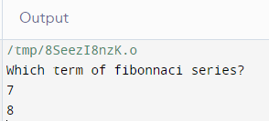

Question 5: Write a program to calculate the Factorial of a number.
Ans5.
#include <stdio.h>
int main()
{
int n, fact;
printf("Enter the number to find factorial of.\n");
scanf("%d", &n);
fact = 1;
for (int i =1; i<=n; i++){
fact = fact*i;
}
printf("The factorial of your no. is %d\n", fact);
return 0;
}

OUTPUT: -
